AUTOMATED RESUME ANALYSIS USING SPACY
- Jenifer ¹, M. Sukanya ²,
Student ¹, Assistant Professor ²,
PG Department of Data Science,
Holy Cross College (Autonomous), Tiruchirappalli
ABSTRACT
In this project, we aim to revolutionize the recruitment process by leveraging Natural Language Processing (NLP) tools, with a primary focus on spaCy, to perform entity recognition on a dataset comprising 200 resumes. The overarching goal is to enable recruiters to swiftly navigate through a large volume of applications, providing an efficient solution for the time-intensive task of candidate screening. Our approach involves the utilization of spaCy, a powerful NLP library, for entity recognition, extracting key information from resumes to streamline the evaluation process. Through the integration of various NLP tools, we plan to enhance the text analysis capabilities, allowing for comprehensive and nuanced understanding of the applicants' profiles. To optimize the efficiency of our system, we have introduced a skills matching feature. This feature enables hiring managers to employ a metric that aids in discerning the alignment between applicants' skills and the requirements of the job role. By incorporating this metric, we aim to provide a quantitative basis for decision-making, allowing recruiters to swiftly identify potential candidates who closely match the desired skill set. The project operates on two primary datasets. The first dataset comprises the textual content of 200 resumes, providing a diverse range of candidate profiles for analysis. The second dataset encompasses a curated list of skills, which will be utilized to construct an entity ruler. This ruler will serve as a valuable resource for the entity recognition process, facilitating the identification and extraction of specific entities related to skills, qualifications, and experience. Through the synergistic integration of spaCy for entity recognition and our custom entity ruler for skills matching, we anticipate a significant reduction in the time and effort traditionally invested in resume screening. The project's outcomes are poised to empower hiring managers with a rapid yet precise mechanism to evaluate and shortlist candidates, expediting the recruitment pipeline and ensuring that only the most qualified applicants progress to the interview stage. This research represents a pioneering effort in utilizing advanced NLP techniques to address the challenges of high-volume recruitment, offering a scalable and effective solution for modern talent acquisition processes.
Keywords: Resume, spaCy, NLP
I. INTRODUCTION
In the fast-paced world of recruitment, the sheer volume of resumes received for a single job opening can be overwhelming for hiring teams. Traditional methods of manually screening and evaluating each application are not only time-consuming but also prone to oversights. In response to these challenges, our project endeavors to redefine the recruitment landscape by harnessing the power of Natural Language Processing (NLP) tools, with a primary focus on spaCy, to conduct a comprehensive analysis of 200 resumes. The core objective of this initiative is to usher in a new era of efficiency and accuracy in the candidate screening process. By leveraging spaCy's advanced capabilities in entity recognition, we aim to automate the extraction of crucial information from resumes, enabling recruiters to swiftly navigate through a large dataset and make well-informed decisions. Our approach involves a strategic integration of spaCy as the primary NLP library, backed by a meticulous entity ruler crafted from a curated list of skills. This dual-pronged strategy not only ensures the extraction of key entities related to skills, qualifications, and experience but also introduces a ground breaking skills matching feature.
This feature provides hiring managers with a quantitative metric, allowing them to assess the alignment between applicants' skills and the job requirements. The project operates on two distinct datasets: the first containing the textual content of 200 resumes, offering a diverse spectrum of candidate profiles, and the second comprising a meticulously curated list of skills. The synergy between spaCy's entity recognition and the custom entity ruler dedicated to skills matching positions our project at the forefront of innovation in resume analysis. Through the seamless integration of NLP techniques, we anticipate a significant reduction in the time and effort traditionally invested in resume screening. This research not only marks a pioneering effort in leveraging advanced NLP tools for high-volume recruitment but also promises a scalable and effective solution for modern talent acquisition processes. By empowering hiring managers with a rapid yet precise mechanism for candidate evaluation, our project aims to streamline the recruitment pipeline, ensuring that only the most qualified applicants progress to the interview stage.
In the ever-evolving realm of recruitment, the inundation of resumes for a single job opening can overwhelm hiring teams. The conventional method of manual screening and evaluation is not only time-consuming but also prone to oversights. In response to these challenges, our groundbreaking project seeks to redefine the recruitment landscape by harnessing the power of Natural Language Processing (NLP) tools, with a specific focus on the spaCy library. This initiative aims to conduct a thorough analysis of 200 resumes, introducing a new era of efficiency and accuracy to the candidate screening process. Our primary objective is to automate the extraction of crucial information from resumes, enabling recruiters to navigate swiftly through a vast dataset and make well-informed decisions. We leverage spaCy's advanced capabilities in entity recognition, with a strategic integration as the primary NLP library. This integration is further enhanced by a meticulous entity ruler crafted from a curated list of skills, providing a dual-pronged strategy for extracting key entities related to skills, qualifications, and experience. The innovative skills matching feature introduced in our approach offers hiring managers a quantitative metric to assess the alignment between applicants' skills and job requirements. By introducing this groundbreaking feature, we provide a unique solution that not only extracts information but also evaluates its relevance, thus streamlining the decision-making process for recruiters. In the dynamic and fast-paced realm of recruitment, the inundation of resumes for a single job opening poses a formidable challenge for hiring teams. The traditional method of manual screening and evaluation, while a staple in the hiring process, becomes increasingly inefficient and error-prone when faced with the sheer volume of applications. Recognizing these challenges, our innovative project emerges as a groundbreaking effort to redefine the recruitment landscape. Leveraging the transformative capabilities of Natural Language Processing (NLP) tools, with a specific emphasis on the spaCy library, our initiative aims to introduce a new era of efficiency and accuracy to the candidate screening process. The core objective of our project is to address the time-consuming nature of traditional resume screening methods by automating the extraction of crucial information from resumes. With a focus on analyzing a dataset comprising 200 resumes, our goal is to empower recruiters to swiftly navigate through this substantial volume of applications while ensuring well-informed decision-making. At the heart of our approach is the strategic integration of spaCy as the primary NLP library, renowned for its advanced entity recognition capabilities.
To enhance the precision of our automated resume analysis, we introduce a dual-pronged strategy by complementing spaCy with a meticulously crafted entity ruler. This ruler is derived from a curated list of skills, allowing for the extraction of key entities related to skills, qualifications, and experience. However, our project does not stop at information extraction. We aim to set a new standard in resume analysis by introducing a ground breaking skills matching feature. This innovative feature goes beyond mere entity extraction; it provides hiring managers with a quantitative metric to assess the alignment between applicants' skills and job requirements. By introducing this unique solution, our project contributes to streamlining the decision-making process for recruiters, ensuring not only the extraction of information but also its evaluation for relevance. The project operates on two distinct datasets: the first containing the textual content of 200 resumes, offering a diverse spectrum of candidate profiles, and the second comprising a meticulously curated list of skills.
The strategic synergy between spaCy's entity recognition and our custom entity ruler positions our project at the forefront of innovation in resume analysis. As we anticipate a significant reduction in the time and effort traditionally invested in resume screening, this research marks a pioneering effort in leveraging advanced NLP tools for high-volume recruitment. By empowering hiring managers with a rapid yet precise mechanism for candidate evaluation, our project aims to streamline the recruitment pipeline, ensuring that only the most qualified applicants progress to the interview stage. In the ever-evolving realm of recruitment, our project represents a beacon of progress, promising a scalable and effective solution for modern talent acquisition processes.
II. REVIEW OF LITERATURE
Channabasamma et al [1]: This paper suggests a machine learning method for phrase matching in resumes, utilizing the advanced natural language processing (NLP) library spaCy to extract particular skills. Like a human recruiter, it is capable of analyzing resumes and extracting comprehensive information. In order to classify people according to their level of expatriation, it counts the sentences during parsing. Data visualization with matplotlib can expedite the decision-making process. It is possible to weed out candidates by comparing them side by side.
Chavare, Dipti Suhas et al [2]: This article uses advanced Natural Language Processing to automate the screening of resumes. Our methodology assists recruiters in quickly screening resumes in accordance with job descriptions. By automatically extracting the necessary entities from resumes using the Spacy NER model, it streamlines the hiring process. Additionally, joint NER and relation extraction offer a whole new way to retrieve information using knowledge graphs, allowing you to explore different nodes to uncover hidden relationships.
Satheesh, K., A. Jahnavi et al [3]: This paper inefficiencies of manual resume screening in traditional hiring processes and proposes an automated solution using advanced Natural Language Processing (NLP) within the realm of Machine Learning. The model employs Spacy NER for entity extraction, streamlining the screening process and providing recruiters with a graphical representation of candidate scores. This approach not only accelerates hiring but also enhances efficiency by enabling recruiters to swiftly identify and select qualified candidates based on their individual scores.
Shukla, Anant [4]: Beyond simple spell checking, the applicant tracking system (ATS) grades applications using cutting edge AI technology based on many checks that hiring managers and recruiters review. In particular, the platform assesses word choice strength and verifies application style and brevity in order to analyze the impact of the application. In a similar vein, it evaluates every application bullet point and looks for important components including length, word choice, filler words, keywords, and buzzwords.
Vanetik, N. and Kogan [5]: We provide a dataset of software developer resumes in this paper, taken from a public Telegram channel devoted to Israeli hi-tech job applications. Furthermore, to attain state-of-the-art performance in resume matching, we offer an NLP-based method that makes use of named entities, keywords, and neural sentence representations. We compare our method against the top resume-vacancy matching system and show its superiority using both automatic and human annotations.
Bhoir, Nirmiti et al [6]: The two algorithms' best features are combined in this work to obtain highly accurate and effective resume data collection. We conducted experiments to measure the effectiveness of our proposed approach using a dataset of resumes. The results show how accurately our system was able to retrieve relevant data, such as candidate names, contact details, qualifications, job history, and other relevant attributes.
Brindashree, B.V. and Pushphavathi [7]: The decision tree machine learning model, which had a 70% accuracy rate, was trained to make the prediction. The data's precision, recall, and f1 score are acquired and used to assess how successfully the data was trained. Overall, the initiative will streamline HR duties and automate procedures, which will shorten the duration of the hiring process.
S. Hashwanth et al [8]: Recruiters may easily shortlist resumes fast and effectively by processing the document ranking and displaying the final rankings in descending order based on the resume score. Instead of going through piles of unqualified resumes, recruiters may select the necessary candidates based on the scores.
Tanberk, Senem et al [9]: The suggested resume matching framework lets managers or recruiters choose the top-scoring applicants by precisely extracting pertinent information from resumes and displaying the similarity results of the candidates through sorting and ranking.
Chavare, Dipti Suhas et al [10]: This article uses advanced Natural Language Processing to automate the screening of resumes. Our methodology assists recruiters in quickly screening resumes in accordance with job descriptions. By automatically extracting the necessary entities from resumes using the Spacy NER model, it streamlines the hiring process. Additionally, joint NER and relation extraction offer a whole new way to retrieve information using knowledge graphs, allowing you to explore different nodes to uncover hidden relationships.
Sruthi, P., Adithya et al [11]: The information on the resume can be analysed and understood easily as NLP has the capability to understand and parse the information on the resume and extract the desired information efficiently. With the additional help from Python and its packages like streamlit, pymysql, etc. we can store the extracted data and give a rating based on the analysis of the stored data. After the rating is generated, we recommend some modifications like: adding sentences like my hobbies are, my goal is, add objectives, and add declaration and more. We also suggest a few sources through which the user can enhance their skills.
Nimet, Gökhan Akgün et al [12]: The paper introduces robust techniques for information extraction from mixed resume formats and job advertisements, leveraging the capabilities of machine learning and deep learning methods. These methods aim to enhance the efficiency and effectiveness of extracting relevant information from diverse sources, such as resumes and job ads. The proposed approaches address the challenges posed by mixed formats, showcasing their power in handling complex data structures. Overall, the paper contributes valuable insights into advancing information extraction processes in the context of employment-related documents.
III. PROBLEM STATEMENT
In today's competitive job market, the influx of job applications inundates recruiters, making it increasingly challenging for them to efficiently sift through numerous resumes to identify suitable candidates. This overload often results in time-consuming manual screening processes, leading to delays in hiring and potential oversight of qualified individuals. Moreover, traditional methods of resume analysis lack the sophistication needed to extract valuable insights from text data, hindering recruiters' ability to make informed decisions swiftly. The existing tools and techniques for resume analysis often fall short in accurately identifying relevant information such as skills, experiences, and qualifications. Manual parsing of resumes is labor-intensive and prone to human error, while keyword-based approaches lack the nuance to discern contextual relevance effectively. Additionally, the absence of automated mechanisms for skills matching further compounds the problem, as recruiters struggle to efficiently gauge candidates' suitability based on their qualifications relative to job requirements. Consequently, there is a pressing need for advanced natural language processing (NLP) techniques that can streamline the resume screening process and provide recruiters with actionable insights to expedite candidate selection while ensuring optimal match for job roles. Addressing these challenges requires leveraging cutting-edge NLP technologies such as spaCy for entity recognition and entity ruling, alongside robust algorithms for skills matching. However, the integration and optimization of these tools within the context of resume analysis pose significant technical and methodological challenges. Issues such as data preprocessing, model training, and validation of results need to be meticulously addressed to ensure the reliability and accuracy of the system. Furthermore, the practical implementation of such a system must consider scalability, usability, and compatibility with existing recruitment workflows to maximize its utility for recruiters and hiring managers. Thus, this project aims to develop an innovative solution that harnesses the power of NLP to revolutionize resume analysis, enabling recruiters to expedite candidate selection and enhance hiring efficiency in today's fast-paced job market landscape.
VI. METHODOLOGY
The methodology for Automated Resume Analysis Using spaCy involves several key steps. Firstly, the system begins with the collection of resumes in various formats, such as PDF or DOCX. These resumes are then parsed using spaCy to extract the text content. Next, spaCy's NLP capabilities are leveraged for tasks such as named entity recognition (NER) and part-of-speech (POS) tagging to identify and extract key information from the resumes, including education history, work experience, skills, and achievements. The extracted data is then stored in a structured format in a database for easy retrieval and analysis. Additionally, the system incorporates functionalities for keyword matching and sentiment analysis to evaluate candidate suitability and match with job requirements. Finally, the results of the analysis are presented to recruiters through reports and visualizations, aiding them in making informed hiring decisions. This methodology ensures the automation of the resume analysis process using spaCy's powerful NLP capabilities, thereby streamlining the recruitment process and enhancing efficiency.
Our approach operates on two distinct datasets. The first dataset contains the textual content of 200 resumes, presenting a diverse spectrum of candidate profiles. The second dataset comprises a meticulously curated list of skills, forming the backbone of our entity ruler. The synergy between spaCy's entity recognition and the custom entity ruler dedicated to skills matching positions our project at the forefront of innovation in resume analysis. The integration of NLP techniques, specifically spaCy, promises a significant reduction in the time and effort traditionally invested in resume screening. Our meticulously crafted entity ruler, built from a curated list of skills, adds an extra layer of precision to the process. The skills matching feature not only ensures the extraction of key entities related to skills but also introduces a groundbreaking method to quantitatively measure the alignment between applicants' skills and job requirements.

Fig 1: Resume Analysis
4.1. SPACY:
SpaCy, a robust Natural Language Processing (NLP) library, is at the forefront of transforming the landscape of resume analysis. At its core is an advanced Named Entity Recognition (NER) model that revolutionizes the way essential information is extracted from resumes. By seamlessly identifying and categorizing crucial details such as skills, experiences, and qualifications, SpaCy automates and streamlines the resume screening process with unparalleled efficiency.
This technology not only expedites the screening process but also enhances accuracy by precisely extracting relevant entities. Recruiters benefit from a comprehensive understanding of each applicant's profile, enabling them to make well-informed decisions. The intelligent automation offered by SpaCy represents a significant departure from the traditional manual screening approach, alleviating recruiters from the burdensome task of sifting through numerous resumes.
The streamlined and intelligent resume analysis powered by SpaCy empowers recruiters to optimize their decision-making process. With the reduction in time and effort associated with manual screening, recruiters can focus on evaluating the most qualified candidates, ultimately leading to more efficient and successful hiring processes. In summary, SpaCy's role in resume analysis marks a transformative advancement in the field, promising enhanced productivity and informed decision-making for recruiters.
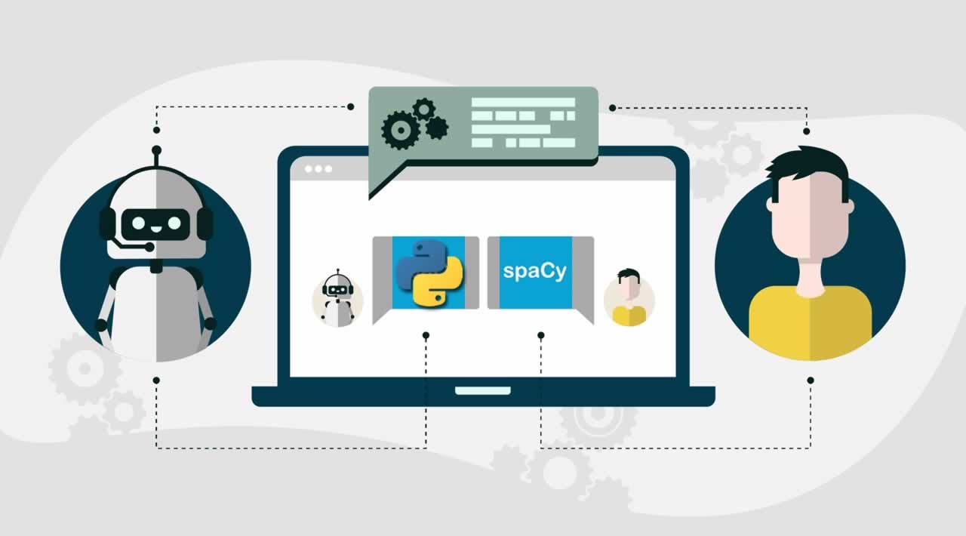
Fig 2: Spacy using NLP
4.2. Dataset:
The dataset for Automated Resume Analysis Using spaCy comprises a diverse collection of resumes sourced from various industries and professions. Each resume within the dataset contains structured information such as education history, work experience, skills, certifications, and contact details. Additionally, the resumes may include unstructured text sections, such as objective statements, job descriptions, and project summaries. The dataset covers a wide range of formats, including PDF, DOCX, and plain text, to simulate real-world scenarios. Furthermore, the dataset includes annotations for named entities, such as organizations, locations, and job titles, to facilitate the training and evaluation of spaCy's NLP models for resume parsing and information extraction. Overall, this comprehensive dataset enables the development and validation of automated resume analysis systems using spaCy, ensuring robust performance across various resume formats and content structures. The CSV dataset includes a unique identifier, "ID," which serves as both a unique identifier and the filename for the respective PDF containing the resume.
"Resume_str" column contains the textual content of the resumes in string format, facilitating text-based analysis and processing.
"Resume_html" column provides the resume data in HTML format, mirroring the original structure as presented during web scraping, enabling detailed examination of formatting and layout.
The "Category" column assigns each resume to a specific job category, offering insights into the field or industry associated with the candidate's background and experience. Job categories within the dataset span a diverse range, encompassing fields such as Human Resources (HR), Information Technology (IT), Education (Teacher), Legal (Advocate), Business Development, Healthcare, Fitness, Agriculture, Business Process Outsourcing (BPO), Sales, Consulting, Digital Media, Automobile, Culinary (Chef), Finance, Apparel, Engineering, Accounting, Construction, Public Relations, Banking, Arts, Aviation, among others. This structured dataset facilitates research and development in automated resume analysis, enabling tasks such as categorization, information extraction, and sentiment analysis, with potential applications in recruitment, talent acquisition, and workforce planning across various industries and professions.
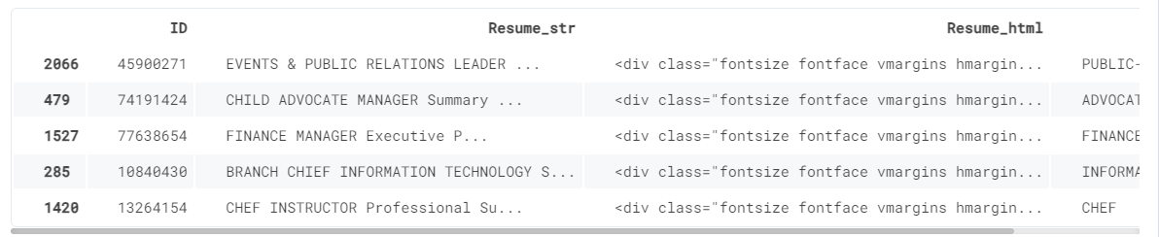

4.3. DATA FLOW DIAGRAM:

Dataset

Cleaning Resume Text
Entity Ruler

Jobs Distribution

Dependency Parsing
Visualization

Entity Recognition
Resume Analysis

pyLDAvis
LDA

Fig 3: Spacy Resume Analysis

4.4. Jobzilla skill patterns:
The Jobzilla skill patterns dataset is a valuable resource for creating a spaCy entity ruler tailored specifically for automated resume analysis. This dataset, stored in JSONL format, comprises labeled skill patterns that represent the diverse range of skills commonly found in resumes across various industries and professions. Each entry in the dataset consists of two main components: the label, which categorizes the skill, and the pattern, which includes different words or phrases used to describe that particular skill. For example, skills such as "Python programming," "data analysis," "customer service," and "project management" are represented by their respective labels and associated patterns. By incorporating this dataset into the spaCy entity ruler, the automated resume analysis system gains the ability to recognize and extract specific skills mentioned in resumes accurately. This enhances the system's capability to parse and analyze resumes efficiently, enabling recruiters to identify qualified candidates based on their skill sets more effectively. Moreover, the Jobzilla skill patterns dataset facilitates continuous improvement and customization of the entity ruler, allowing for the addition of new skills and patterns as the job market evolves over time. Overall, this dataset plays a crucial role in enhancing the accuracy and effectiveness of automated resume analysis using spaCy.
4.5. Resume Dataset:
The resume dataset is read into a Pandas Data Frame using the read_csv function, containing textual information about resumes. To ensure diversity in job categories, the dataset undergoes randomization, where 200 samples are selected from various job categories instead of being restricted to just one. This approach broadens the scope of analysis and facilitates a more comprehensive understanding of skill patterns across different professions and industries. Given the computational constraints and processing time considerations, the dataset is limited to 200 samples, striking a balance between computational efficiency and analytical depth. This sampling strategy allows for efficient analysis while still providing valuable insights into skill patterns and job categories present in resumes.
4.6. Loading spaCy model:
Once the spaCy model has been downloaded using the command "python -m spacy download en_core_web_lg," the next step involves loading the spaCy model into the Python environment. This is accomplished by importing the spaCy library and loading the model using the "spacy.load" function. The loaded model is then stored in a variable, typically named "nlp," which serves as the entry point for accessing spaCy's linguistic features and capabilities. By loading the pre-trained "en_core_web_lg" model, which is a large English language model, the system gains access to a wide range of linguistic annotations and vectors, including part-of-speech tagging, named entity recognition, and word embeddings. This rich linguistic representation provided by spaCy's model forms the foundation for various NLP tasks, including automated resume analysis.
4.7. Entity Ruler:
The addition of an entity ruler pipeline to our spaCy model is a pivotal step in enhancing the capabilities of automated resume analysis. This entity ruler empowers us to define and enforce rules for identifying specific entities within the text, such as skills and job descriptions. By loading a .jsonl file containing labeled patterns for these entities, we can instruct the entity ruler to recognize and annotate instances of these patterns in the resumes. This facilitates precise extraction of relevant information, enabling us to efficiently categorize and analyze resumes based on key attributes like skills and job roles. With the entity ruler in place, our automated resume analysis system becomes more robust and effective, providing recruiters with invaluable insights into candidate qualifications and suitability for various roles. This integration of the entity ruler pipeline represents a significant advancement in our ability to harness the power of spaCy for resume parsing and analysis, ultimately streamlining the recruitment process and enhancing decision-making.
4.8. Skills:
The unique_skills function serves as a crucial component in our automated resume analysis system, enabling us to efficiently process and organize the extracted skills. Once the get_skills function extracts skills from a single resume text, the unique_skills function removes any duplicate entries, ensuring that each skill is represented only once within the resulting array. This step is essential for creating a concise and accurate summary of the skills present in the dataset. By eliminating duplicates, we prevent redundancy and streamline subsequent analysis, allowing us to focus on identifying trends and patterns within the dataset more effectively. Moreover, the unique_skills function enhances the interpretability of the skill data, providing a clear and unambiguous representation of the skills possessed by candidates across various job categories. As a result, the creation of the skill feature, incorporating unique_skills, facilitates comprehensive visualization and analysis of skill trends within the dataset, empowering recruiters to make informed decisions in the talent acquisition process.
- get_skills is going to extract skills from a single text.
- unique_skills will remove duplicates.
4.9. Cleaning Resume Text:
Cleaning the resume text using the NLTK library involves a series of essential steps to preprocess the data effectively. Firstly, we utilize regular expressions (regex) to eliminate hyperlinks, special characters, and punctuations from the text, ensuring that only relevant content remains. Next, we convert the text to lowercase to standardize the case and avoid case sensitivity issues during analysis. The text is then split into an array based on whitespace, facilitating further processing. To normalize the text, we employ lemmatization to reduce words to their base forms, enhancing consistency and reducing the dimensionality of the data. Additionally, we remove English stop words, such as "and," "the," and "is," which carry little semantic meaning and can skew analysis results. Finally, the cleaned and preprocessed text is appended into an array, ready for subsequent analysis tasks. This comprehensive cleaning process ensures that the resume text is appropriately prepared for further analysis and modeling, enabling accurate extraction of meaningful insights and trends from the dataset.
4.10. Applying functions:
Creating Clean_Resume Column: We add a new column called "Clean_Resume" to the dataset and populate it with the cleaned resume text obtained after applying the cleaning functions, including regex cleaning, lowercase conversion, word tokenization, lemmatization, and stopword removal. Creating Skills Column: Another new column called "Skills" is created to store the extracted skills from the cleaned resume text.
Apply the lowering text function to ensure consistency, followed by invoking the get_skills function to extract skills from each resume. Removing Duplicates from Skills Column: After extracting skills from each resume, we remove any duplicate entries within the "Skills" column to ensure that each skill is represented only once for each resume. This step is crucial for accurate analysis and visualization of skill trends within the dataset, as it eliminates redundancy and provides a clear overview of the skills possessed by candidates. By systematically applying these functions to the dataset, we can preprocess the resume text, extract relevant skills, and prepare the data for further analysis, enabling us to gain valuable insights into skill patterns and trends across different job categories.
4.11. Visualization:
In visualizing the job distributions and skill distributions derived from our spaCy-based resume analysis, we aim to provide a comprehensive overview of the dataset's composition and highlight key insights. For job distributions, we'll create bar charts or pie charts depicting the frequency of different job categories within the dataset, allowing us to identify the most prevalent industries or professions. Meanwhile, for skill distributions, we'll utilize word clouds, bar charts, or heatmaps to showcase the frequency and relevance of various skills across different job categories, enabling us to pinpoint the most in-demand skills within each industry. These visualizations offer valuable insights for recruiters and hiring managers, aiding in talent acquisition strategies, skill gap analysis, and workforce planning initiatives.

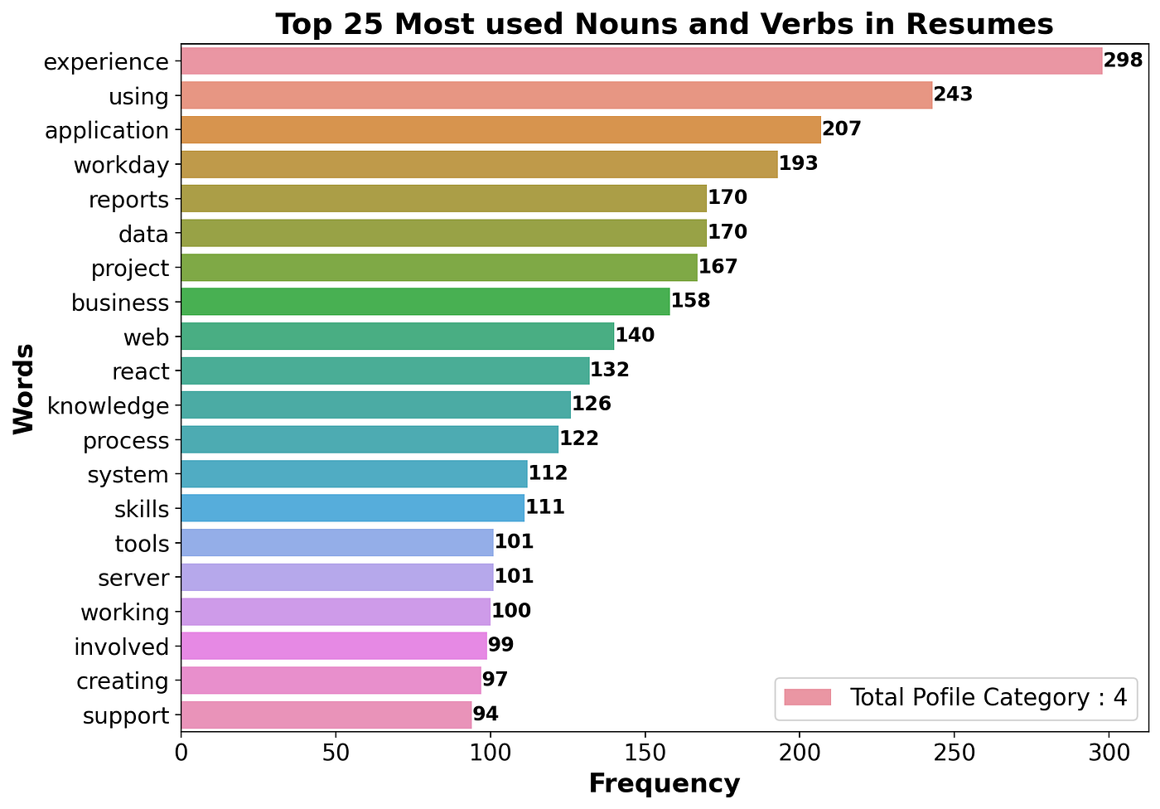
Fig 4: Visualization Table
4.12. Entity Recognition:
The displacy.render function in spaCy is indeed a powerful tool for visualizing entity recognition within raw text data. By leveraging this function, we can generate interactive visualizations that highlight various entities such as skills, organizations, locations, and more within resumes. The visualizations produced by displacy.render provide a user-friendly interface for exploring and understanding the structure of the text, making it easier to identify and extract important information. Additionally, the ability to customize the visualization style and layout further enhances its utility for analyzing resumes and other text documents. Overall, displacy.render is an invaluable feature in spaCy for facilitating entity recognition and gaining insights from textual data in a visually appealing manner.
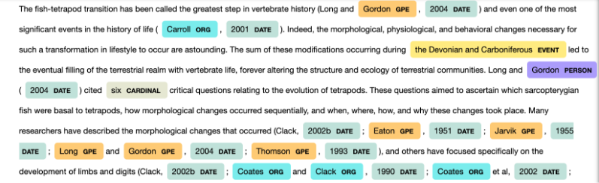

Fig 5: Resume dataset Entity Recognition
4.13. Dependency Parsing:
Indeed, visualizing dependency parsing using spaCy's displacy.render function with the "dep" style is a valuable technique for understanding the grammatical structure and relationships within text data. By specifying the "dep" style, the function generates visual representations of the syntactic dependencies between words in the text, illustrating how each word relates to other words in the sentence through various dependency relationships such as subject, object, modifier, etc. Limiting the visualization to a specific number of words, including spaces, provides a concise and focused view of the dependency structure, making it easier to analyze and interpret. Removing the word limit allows for visualization of the entire text, providing a comprehensive overview of the dependencies present within the document. Overall, visualizing dependency parsing using displays, render offers valuable insights into the linguistic structure of the text, aiding in tasks such as syntactic analysis, information extraction, and natural language understanding.

4.14. Custom Entity Recognition:
In our instance, a new object named SKILL has been added, and it is shown in gray. Colors didn't impress me, and I also wanted to add a job description entity, so I started tinkering with different displace settings.
- Including Job-Category in the ruler of entities.
- Giving each category a unique hue.
- Gradient color additions for SKILL and Job-Category
4.15. Topic Modeling – LDA:
Latent Dirichlet Allocation (LDA) is indeed one of the most widely used topic modeling algorithms. In LDA, each document is represented as a mixture of topics, and each topic is represented as a distribution over words. By analyzing this distribution, LDA infers the underlying topics present in the corpus and assigns documents to these topics based on their word distributions. In this scenario, we create a simple topic model with 4 topics, allowing us to uncover the main themes or subjects present in the corpus. This process enables us to gain insights into the dominant topics across the documents and facilitates tasks such as document categorization, summarization, and information retrieval.
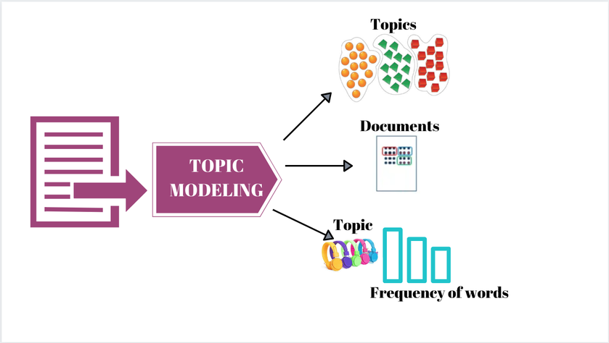
Fig 6: Latent Dirichlet Allocation
4.16. PyLDAvis:
PyLDAvis is indeed a powerful tool for visualizing and interpreting topics generated by topic modeling algorithms such as Latent Dirichlet Allocation (LDA) from Gensim. In the context described, the topics identified by the LDA model exhibit clear thematic patterns:
- Customer-related topics, possibly including discussions about customer service, satisfaction, demographics, and geographical locations such as states and cities.
- Management and marketing themes, indicating discussions on strategic management practices, marketing strategies, campaigns, and market analysis.
- Systems and projects, suggesting conversations about system development, project management methodologies, software engineering, and implementation strategies.
- Financial and company-related topics, likely encompassing discussions on financial management, investment strategies, company performance, and corporate governance.
By visualizing these topics using PyLDAvis, stakeholders can gain deeper insights into the main themes present in the corpus and understand how different topics relate to each other. This visualization aids in topic interpretation, exploration, and refinement, ultimately facilitating a more nuanced understanding of the underlying content.
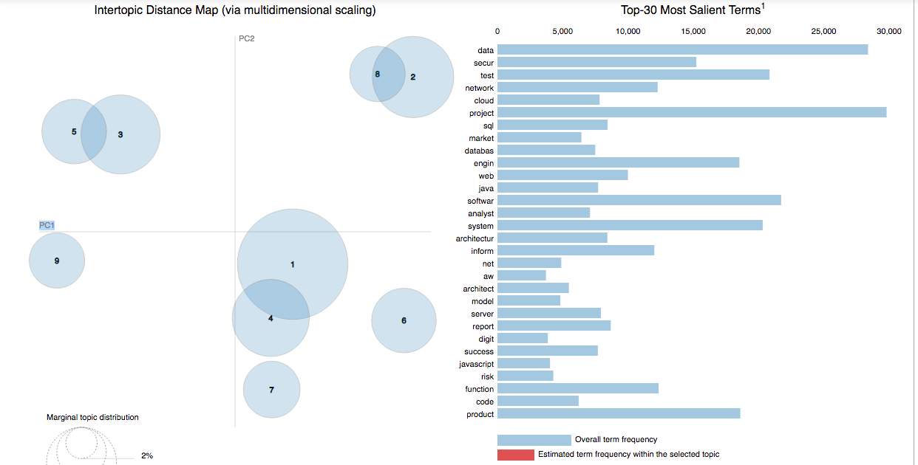
Fig 7: Intertopic Distance Map

V. IMPLEMENTATION
5.1. Jobs Distribution:
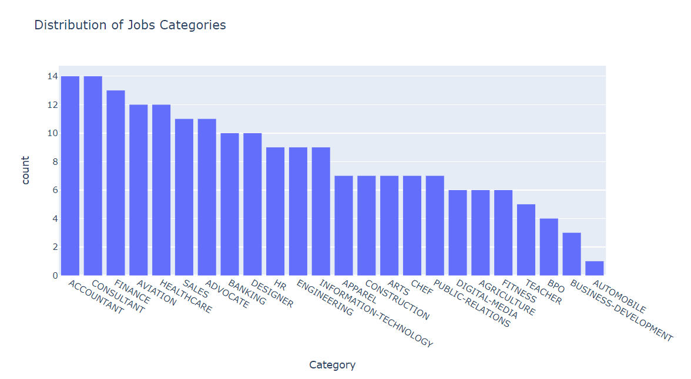
Fig 8: Job Categories
5.2. Skills:
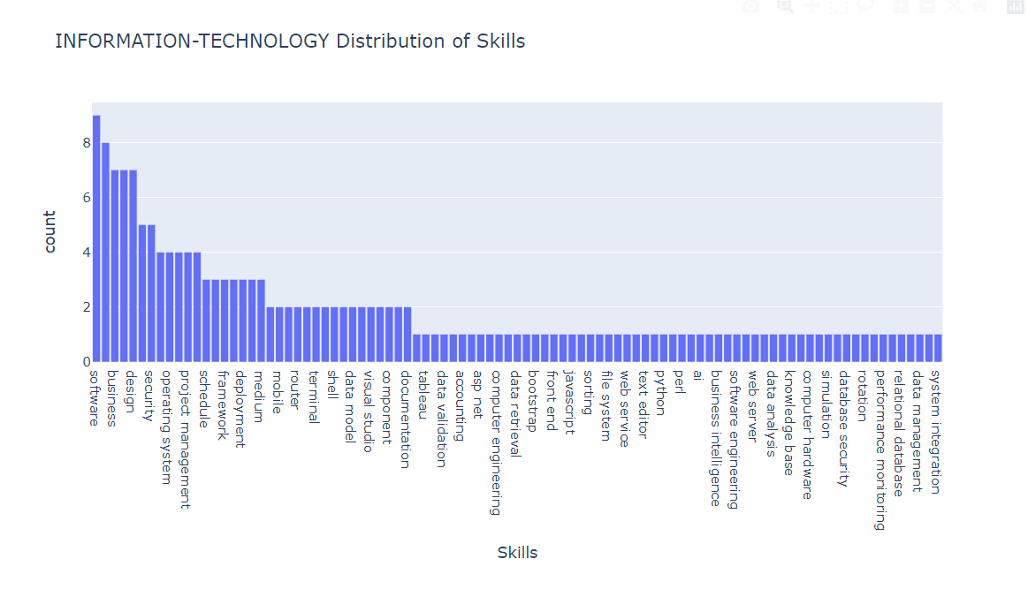
Fig 9: Skill Distribution
5.3. Most used words:
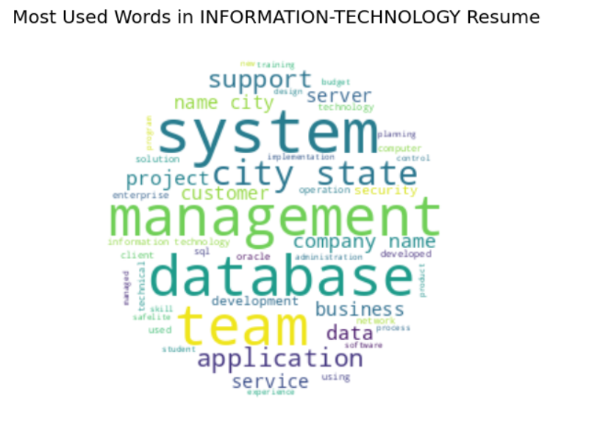
Fig 10: Most Used Words
5.4. Entity Recognition:
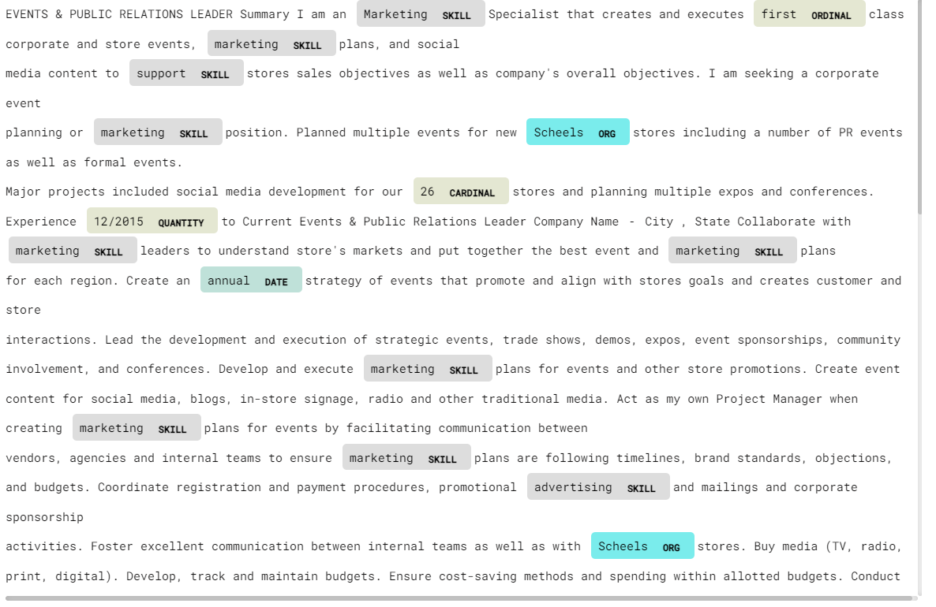
Fig 11: Entity Recognition
5.5. Dependency Parsing:
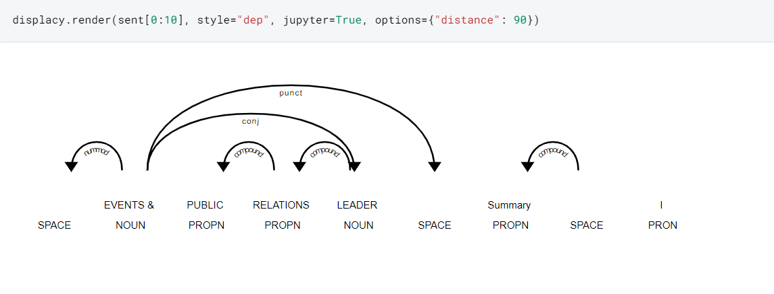
Fig 12: Dependency Parsing
5.6. Custom Entity Recognition:
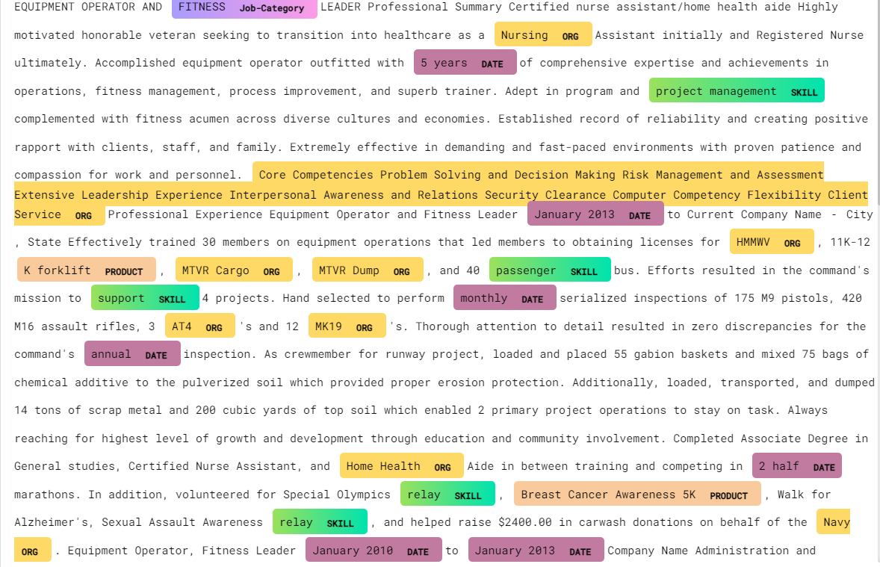
Fig 13: Custom Entity Recognition
5.7. Resume Anlaysis:
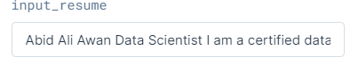
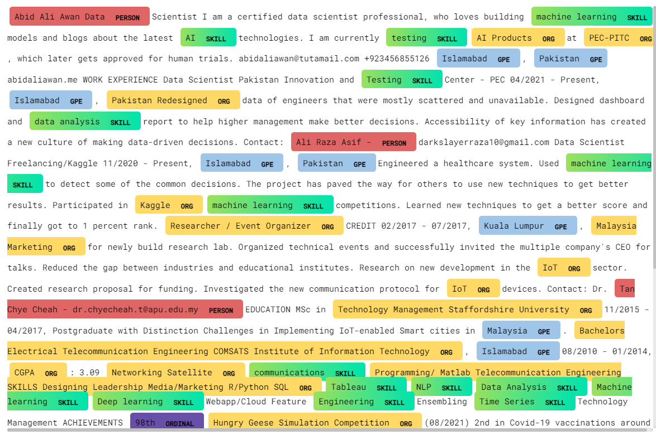
Fig 14: Resume Analysis
5.8. pyLDAvis:
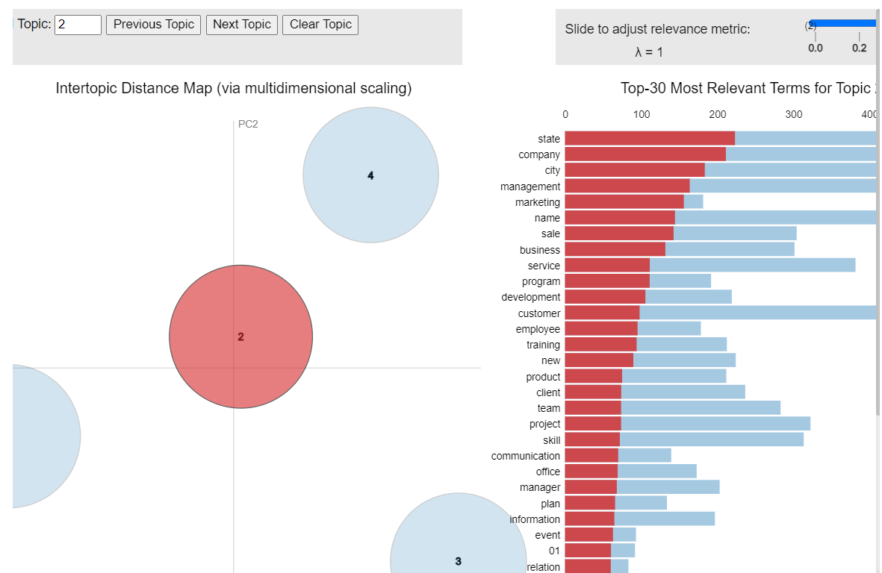
Fig 15: pyLDAvis visualizations
VI. CONCLUSION
In the course of this project, our collaboration with spaCy has been both enlightening and transformative. The extensive leveraging of spaCy's capabilities, particularly through the adept use of the entity ruler, has broadened our approach to entity recognition. The incorporation of customized visualizations, adorned with bespoke colors, has elevated the clarity of our analyses, providing recruiters with a more intuitive and efficient means of navigating through extracted information. As we delved into skills distribution visualization, our project introduced a seamless resume analysis feature, empowering recruiters to swiftly identify and match candidates with the desired skillsets, thereby enhancing the precision of candidate evaluation in the recruitment process. Furthermore, the integration of Latent Dirichlet Allocation (LDA) for topic modeling has been a pivotal addition, offering deeper insights into the inherent themes within textual data. The use of pyLDAvis as a visualization tool has not only enhanced the interpretability of these insights but also contributed to a more comprehensive understanding of the diverse topics encapsulated in the resumes. This multifaceted exploration not only solidified our technical proficiency with spaCy but also shed light on innovative avenues for optimizing the hiring process. The transformative potential of natural language processing in talent acquisition and recruitment strategies has been underscored, marking this project as a significant step towards reshaping and modernizing the landscape of candidate screening and evaluation.
REFERENCES
[1] SW. Kim, JM. Gil, Research paper classification systems based on TF-IDF and LDA schemes. Hum. Cent. Comput. Inf. Sci. 9, 30 (2019).
[2] F. N. A. Al Omran and C. Treude, "Choosing an NLP Library for Analyzing Software Documentation: A Systematic Literature Review and a Series of Experiments," 2017 IEEE/ACM 14th International Conference on Mining Software Repositories (MSR), Buenos Aires, 2017, pp. 187-197.
[3] Zhang C, Wang H (2018) ResumeVis: a visual analytics system to discover semantic information in semi-structured resume data. ACM Trans Intell Syst Technol 10(1), Article 8, 25 p. https://doi.org/10.1145/3230707.
[4] Chala, S.A.; Ansari, F.; Fathi, M.; Tijdens, K. Semantic matching of job seeker to vacancy: A bidirectional approach. Int. J. Manpow. 2018, 39, 1047–1063.
[5] Pudasaini, S.; Shakya, S.; Lamichhane, S.; Adhikari, S.; Tamang, A.; Adhikari, S. Scoring of Resume and Job Description Using Word2vec and Matching Them Using Gale-Shapley Algorithm. In Proceedings of the ICOECA 2021, Bangalore, India, 18–19 February 2021.
[6] Kawan, S.; Mohanty, M.N. Multiclass Resume Categorization Using Data Mining. Int. J. Electr. Eng. Technol. 2020, 11, 267–274.
[7] R. P. Kumar, S. S. Chowdhary and R. Bhatia, "A machine learning approach for automation of resume recommendation system", Procedia Computer Science, vol. 167, pp. 2318-2327, 2020.
[8] T. Quynh and T.T. Dang, "Automatic Process Resume In Talent Pool By Applying Natural Language Processing", International Conference On Logistics And Industrial Engineering 2021, 2021.
[9] S. K. Kopparapu, "Automatic extraction of usable information from unstructured resumes to aid search," 2010 IEEE International Conference on Progress in Informatics and Computing, Shanghai, 2010, pp. 99-103.
[10] Chandola, D., Garg, A., Maurya, A., Kushwaha, A.: Online Resume Parsing System Using Text Analytics (2015). [online] Jmdet.com. Available at: http://www.jmdet.com/wp-content/uploads/2015/08/CR9.pdf. Accessed 24 Sept. 2020.
[11] Singh, S.: Natural Language Processing for Information Extraction (2018). arXiv, [online] Available at: https://arxiv.org/pdf/1807.02383.pdf. Accessed 20 Jan. 2021.
[12] C. H. Ayishathahira, C. Sreejith and C. Raseek, "Combination of Neural Networks and Conditional Random Fields for Efficient Resume Parsing", 2018 International CET Conference on Control Communication and Computing (IC4), pp. 388-393, 2018, July.
[13] Kopparapu, S.K., 2010, December. Automatic extraction of usable information from unstructured resumes to aid search. In 2010 IEEE International Conference on Progress in Informatics and Computing (Vol. 1, pp. 99-103). IEEE.
[14] A. Zaroor, M. Maree, MuathSabhaJRC, A job post and resume classification system for online recruitment, International Conference on tools with Artifical Intelligence, (2017).
[15] Kolluri, Johnson and Razia, Shaik and Nayak, Soumya Ranjan, Text Classification Using Machine Learning and Deep Learning Models. International Conference on Artificial Intelligence in Manufacturing & Renewable Energy (ICAIMRE) (2019).
[16] Anushka Agarwal, Dr. Senthilkumar. "Resume Recommendation System Using Cosine Similarity." International Research Journal of Modernization in Engineering Technology and Science, April 2022.
[17] Pradeep Kumar Roya, Sarabjeet Singh Chowdhary, Rocky Bhatia. "A Machine Learning approach for automation of Resume Recommendation system." International Conference on Computational Intelligence and Data Science (ICCIDS 2019).

